Baldivis Secondary College

Semester One Examination, 2016

Question/Answer Booklet

MATHEMATICS

SOLUTIONS
APPLICATIONS
UNIT 1

Section One:

Calculator-free

Student Number: In figures

In words

Your name

Time allowed for this section
Reading time before commencing work: five minutes
Working time for section: fifty minutes

Materials required/recommended for this section
To be provided by the supervisor
This Question/Answer Booklet
Formula Sheet

To be provided by the candidate
Standard items: pens (blue/black preferred), pencils (including coloured), sharpener, correction fluid/tape, eraser, ruler, highlighters

Special items: nil

Important note to candidates
No other items may be taken into the examination room. It is your responsibility to ensure that you do not have any unauthorised notes or other items of a non-personal nature in the examination room. If you have any unauthorised material with you, hand it to the supervisor before reading any further.

Structure of this paper

Section | Number of questions available | Number of questions to be answered | Working  time (minutes) | Marks available | Percentage of exam
Section One:  Calculator-free | 7 | 7 | 50 | 52 | 35
Section Two:  Calculator-assumed | 12 | 12 | 100 | 98 | 65
 |  |  | Total | 150 | 100

Instructions to candidates

- The rules for the conduct of examinations are detailed in the school handbook. Sitting this examination implies that you agree to abide by these rules.

- Write your answers in this Question/Answer Booklet.

- You must be careful to confine your response to the specific question asked and to follow any instructions that are specified to a particular question.

- Spare pages are included at the end of this booklet. They can be used for planning your responses and/or as additional space if required to continue an answer.
- Planning: If you use the spare pages for planning, indicate this clearly at the top of the page.
- Continuing an answer: If you need to use the space to continue an answer, indicate in the original answer space where the answer is continued, i.e. give the page number. Fill in the number of the question that you are continuing to answer at the top of the page.

- Show all your working clearly. Your working should be in sufficient detail to allow your answers to be checked readily and for marks to be awarded for reasoning. Incorrect answers given without supporting reasoning cannot be allocated any marks. For any question or part question worth more than two marks, valid working or justification is required to receive full marks. If you repeat any question, ensure that you cancel the answer you do not wish to have marked.

- It is recommended that you do not use pencil, except in diagrams.

- The Formula Sheet is not to be handed in with your Question/Answer Booklet.

Section One: Calculator-free 35% (52 Marks)
This section has seven (7) questions. Answer all questions. Write your answers in the spaces provided.

Working time for this section is 50 minutes.

Question 1 (5 marks)
(a) Evaluate

(i) . (1 mark)
Solution
Specific behaviours
evaluates calculation

(ii) when . (1 mark)
Solution
Specific behaviours
substitutes and evaluates calculation

(b) Given , determine

(i) A when and . (1 mark)
Solution
Specific behaviours
substitutes and evaluates calculation

(ii) h when and . (2 marks)
Solution
Specific behaviours
substitutes and simplifies
solves for h

Question 2 (8 marks)
A casual worker submitted the weekly time sheet below. On Saturdays and Sundays, casuals are paid time and a half and double time respectively.

Time sheet | Normal hourly pay rate |  |  | $20
 | Mon | Tue | Wed | Thu | Fri | Sat | Sun
Hours worked | - | - | - | 3.5 | 5.5 | 4 | 5

(a) How many hours did the casual worker work during this week? (1 mark)
Solution
Specific behaviours
states hours worked

(b) How much did the casual worker earn

(i) on Friday? (1 mark)
Solution
Specific behaviours
calculates earnings

(ii) on Saturday? (1 mark)
Solution
Specific behaviours
calculates earnings

(iii) for this week's work? (2 marks)
Solution
Specific behaviours
calculates Thursday's and Sunday's earnings
calculates total earnings

(c) The previous week, the casual worker had $30 deducted for PAYG tax from their total earnings of $400. What percentage of their week's earnings was this? (2 marks)
Solution
Specific behaviours
writes calculation to determine percentage
determines percentage

(d) If casual workers were awarded a 4% pay increase, what would the new normal hourly rate become? (1 mark)
Solution
Specific behaviours
calculates new rate

Question 3 (5 marks)
The number of different bus services that run between four locations is shown in the table below and also in the matrix M.

 |  | To
 |  | A | B | C | D
From | A | 0 | 1 | 1 | 0
 | B | 2 | 0 | 2 | 0
 | C | 1 | 1 | 0 | 1
 | D | 0 | 0 | 1 | 0

(a) Briefly explain the information shown in the matrix (1 mark)
Solution
The number of ways to travel from one location to another using two bus services.
Specific behaviours
explanation

(b) Complete the diagram below to show the information in the table. (2 marks)

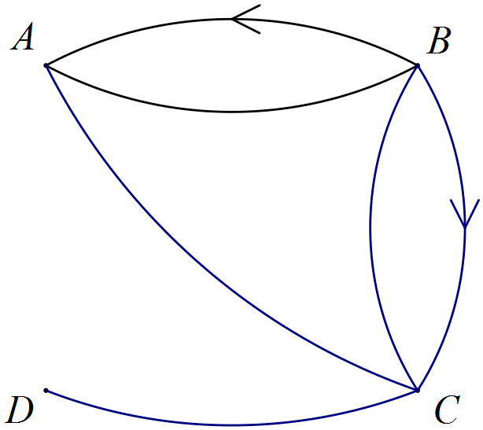
Solution
See diagram
Specific behaviours
adds the four missing edges
includes direction on one edge from B to C

(c) State the number of ways to travel from D to B using two bus services. (1 mark)
Solution
One way
Specific behaviours

(d) How many more ways are there to travel from B to C than from C to B, using either one or two bus services? (1 mark)
Solution
B to C: , C to B: . There are 2 more ways.
Specific behaviours
states number of ways.

Question 4 (10 marks)
Consider matrices , , , and .

(a) Explain which two, if any, of the five matrices can be added together. (2 marks)
Solution
None of the matrices, because no two of them have the same dimensions.
Specific behaviours
states none
states reason

(b) Calculate . (2 marks)
Solution
Specific behaviours
calculates product
determines final matrix

(c) Determine the values of x and y if . (2 marks)
Solution
Specific behaviours
determines x
determines y

(d) Calculate , where I is the identity matrix. (2 marks)
Solution
Specific behaviours
calculates square
determines final result

(e) Determine an order in which all five matrices can be multiplied together and state the dimensions of the resulting matrix. (2 marks)
Solution
or . Dimensions of result are .
Specific behaviours
lists either order
states dimensions

Question 5 (7 marks)
(a) Write the following scales as a ratio in simplest form, without units.

(i) 5 cm : 1 m. (1 mark)
Solution
Specific behaviours
states simplified ratio

(ii) 20 mm : 1 km. (1 mark)
Solution
Specific behaviours
states simplified ratio

(b) The length of a house is 12.6 m. Determine the length of the house on a drawing with a scale of 1:200. (2 marks)
Solution
Specific behaviours
converts using scale
states units

(c) Two similar triangles are shown below. Determine the lengths x and y. (3 marks)

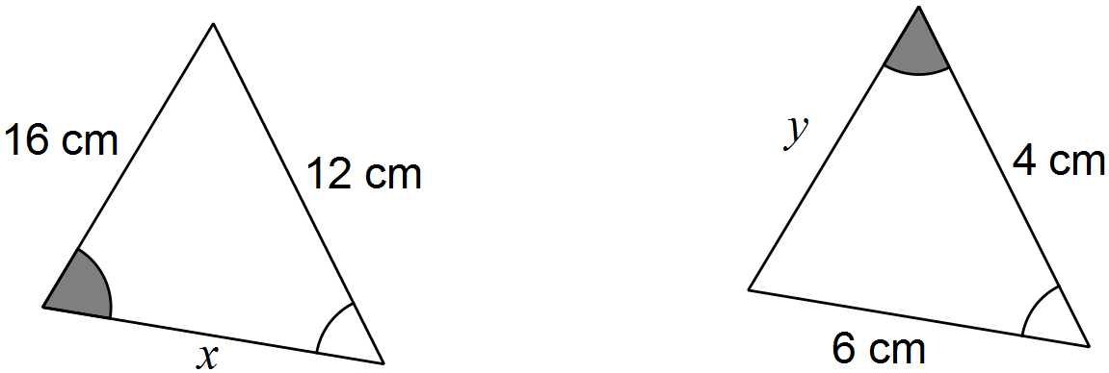
Solution
Specific behaviours
calculates scale factor
determines x
determines y

Question 6 (8 marks)
A model sculpture stood 45 cm tall and had a surface area of 2 500 cm². When the actual sculpture was completed, it was a perfect enlargement of the model and stood 4.5 m tall.

You may wish to recall that 10 000 cm² = 1 m² and 1 000 000 cm³ = 1 m³.

Determine

(a) the linear scale factor of the model to the actual sculpture. (2 marks)
Solution
Specific behaviours
adjust units
determines scale factor

(b) the surface area of the actual sculpture, in square metres. (3 marks)
Solution
Specific behaviours
determines area scale factor
multiplies by area scale factor
adjusts units

(c) the volume of the model in cubic centimetres, given that the actual sculpture had a volume of 5 m³. (3 marks)
Solution
Specific behaviours
adjust units
determines volume scale factor
divides by volume scale factor

Question 7 (9 marks)
Fred, Gail and Harry worked in a motor vehicle dealership. During May they sold 11, 14 and 12 cars and 5, 1 and 2 vans respectively. In the following month, the three sold a total of 30 cars and 10 vans, of which Fred sold 13 cars and 4 vans and Gail sold 9 cars and 3 vans.

(a) Organise the above information into two matrices to show the number of cars and vans sold by Fred, Gail and Harry during May and June. (3 marks)
Solution
NB May choose 3x2 instead of 2x3 matrices
Specific behaviours
writes matrix for May
calculates missing values for Harry for June
writes matrix for June

(b) Write a matrix calculation to determine the change in the number of cars and vans sold by Fred, Gail and Harry from May to June, and write the answer to this calculation. (2 marks)
Solution
Specific behaviours
writes May matrix subtracted from June matrix
writes difference

(c) Fred, Gail and Harry are paid $5 000, $ 4 800 and $ 4 500 per month respectively. They are also paid bonuses of $200 for each car they sell and $300 for each van in any given month.

(i) Write down a calculation involving three matrices, that would result in a matrix showing the monthly pay owed to Fred, Gail and Harry for the month of May.
(2 marks)
Solution
Specific behaviours
pre-multiplies May matrix by bonus matrix
adds monthly wages matrix

(ii) Evaluate your answer to (i). (2 mark)
Solution
Specific behaviours
multiplies matrices
adds matrices

Additional working space

Question number: _________

© 2016 WA Exam Papers. Baldivis Secondary College has a non-exclusive licence to copy and communicate this paper for non-commercial, educational use within the school. No other copying, communication or use is permitted without the express written permission of WA Exam Papers.

